**../../../../../../../Pictures/ARA/Pics/ARA%20LOGO/ARA%20master%20shield%20lo KENT ACTIVE ../../../../../../../Pictures/ARA/Pics/ARA%20LOGO/ARA%20master%20shield%20lo**

**THE NEWSLETTER OF THE KENT ACTIVE RETIREMENT ASSOCIATION**

**Volume Seven A Pepppering of 2022 No. 88 Part 1**

***Circulation: Pumping***

***“Do not think of retirement as banging your head against a closing a door,***

***rather think of it as someone opening the door, and you falling through it”.***

**John Handyman** ***(Fond of the Association)***

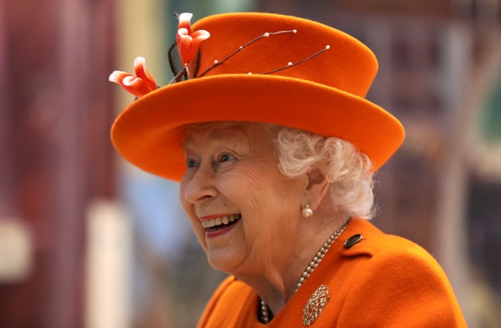

**In Memory of a Life of Service. “…*We will meet again!”***

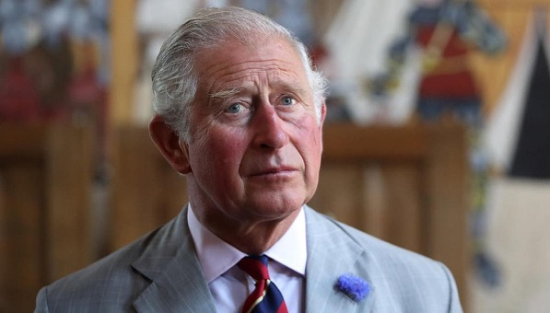

***Long Live The King.***

**Dear Members,**

**I hope you are all keeping well.**

**Due to the amount of activity within KentARA, we have had to keep on updating the Kent Active to keep up, and this includes me rewriting my message to include the immensely sad passing of our Queen – God Bless Her! We were so lucky to live during her reign, and feel King Charles the Third is a ‘chip off the same block’ – so to speak.**

**In the Kent Active you will find various references to the wonderful Platinum Jubilee Celebrations, that I know many clubs have marked with various parties, and this has had a wonderful effect on our morale, as it seemed perfectly timed, against the passing back drop of Covid-19, to get us back into the art of socialising again.**

**We do have a ‘Race Afternoon’ with a Cream Tea, booked for the 20th October at Ditton Community Centre. Do make sure you get your tickets from Lin Martin our 2022 General Club secretary… did I say it includes an Afternoon Cream Tea!**

**Our good news is that Tracey Crouch, (Chatham & Aylesford’s M.P.) has agreed to be our new President, and we look forward to welcoming Tracey to one of our forthcoming Kentara events - TBA.**

***Hugs all round from the KentARA Committee***

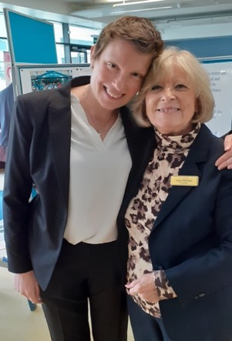

***TC MP the new KentARA Presie, with our star JR.***

**What weather we have enjoyed this summer!**

**There has been lots going on with Kentara, we had our John Hardiman ‘Short Mat Bowls Competition’ on the 25th August, which Bearsted club won, with Hadara coming a very close second. It was a good return to normality, with 8 teams entering, and a very good day was had by all.**

**Unfortunately, we had to close ShepARA as we could not get a committee to run the club; it was very sad because the club had been going for over 30 years. Maybe, it will reopen another day.**

**Gladys Forsythe from Ashford club, reached the grand age of 100 on 21st August. Gladys was the founder member of the Ashford club in 1984. Gladys also opened South Ashford Ara, and was Chairman for both.**

**What an incredible achievement!**

**We would like to thank Gladys for all her hard work, and support over the years to KentARA. Ian and Lyn Sharpe of Ashford club, put on a lovely afternoon for Gladys, with lots of flowers, cake and champagne. Ashford’s Mayor was invited, and Gladys enjoyed her afternoon very much - she is a lovely lady.**

**The Cruise to Norway eventually slipped anchor on the 14th September, and everyone was very excited, after waiting so patiently for so long with our other clubs.**

**The ‘Ten Pin Bowling Tournament’ is on 3rd November, at the ‘Hollywood Bowl’ in Strood, Rochester.**

**The ‘Tea Dance’ is on 11th November at Ditton Community Centre, with tickets from Gerald Bentham.**

**We end the year with a ‘Grand Christmas Concert’ at Ditton Community Centre, on December 8th, with a raft of top class entertainers, like the Lara Music Ukulele & Singers’, Mike ‘Smoothie’ Harris’, ‘Barbara Snow & Richard Suttons ‘Sax Duo’, finishing with the brilliant ‘Military Wives Choir’, tickets will go quick! Enjoy the rest of the year!**

**Much love to you all**

**Joan Rhodes X**

**KentARA Chairlady**

**(01732) 844 953** [**rhodjo@aol.com**](mailto:rhodjo@aol.com)

# ../Christmas%20Concert/KENTARA%20CHRISTMAS%20POSTER.pdf

**The**

# **KENTARA CHRISTMAS CONCERT 2022**

**Thursday 8th DECEMBER 2pm – 6pm**

**Ditton Community Centre**

**Kiln Barn Road, Ditton Aylesford, Kent. ME20 6AH**

**PLEASE MAY WE HAVE ………….. TICKETS**

**FOR THE ABOVE EVENT@ £10 PER PERSON**

# **ARA:** ___________________________________

**ADDRESS:**

**NAME OF CONTACT:**

**TEL:**

**EMAIL:**

# **Date:** ____________________________________

**Please send cheques made payable to: ‘KENTARA’**

**£10 PER PERSON, Including Tea, Coffee & Biscuits.**

**TO:-**

**Mr. Gerry Waters**

**11, Tintern Road,**

**Maidstone Kent,**

**ME16 0RT**

**01622 671691**

**Email:** [**gerrywaters1401@yahoo.co.uk**](mailto:gerrywaters1401@yahoo.co.uk)

**REQUESTS FOR TICKETS MUST BE RECEIVED BY Tuesday 8th NOVEMBER, PLEASE.**

**RAMARA (RAMSGATE) Update 2022**

***Marching Forward***

**A number of Club Members managed to join on some events towards the end of last year which included Bournemouth holiday, Weymouth Tinsel and Turkey, our own Christmas Tea Party, a Christmas lunch, and the last event being our New Year’s Eve party where everyone had a really good time, dancing and playing games. The night was very successful!**

**We are not aware of any complaints following these activities, particularly as many of them involved taking some precautions re Covid. It was not pleasant to wear a mask on long coach journeys, nor when dancing or participating in games, however, we are delighted to be able to say, with the precautions we had in place no reports of any members who took part in our planned activities contracted the virus.**

**Activities have now increased and include:- Line Dancing, Sequence Dancing, (both also with beginners classes), Gentle Exercising, Indoor Bowls, Table Tennis, Coffee Morning, Quiz meetings, Beetle Drive, and club Meetings with speakers and entertainers. Soon our Bat & Trap will be back as well.**

**Our speakers so far this year have included ‘Sit Down Exercises’ to music, which went down a treat and is booked again. A talk about ‘Old Thanet’ which was found very interesting. 30 member of the Thanet Rock Choir came to sing to us, which was thoroughly enjoyed by all. Later in the year we have a Talk from the Air Ambulance, and a Yule Lady Band.oliday to the Isle of Wight**

**Also arranged is an Easter Tea in April, where wearing yellow & Easter Bonnets are optional, a St. Georges Tea Dance with a Theme of Red and White. In June there was our Strawberry Tea Party, a Summer Fair, and our Christmas Tea.**

**In the meantime, some of our lady members are still knitting squares for Blankets, and we have been able to deliver some to the Quex Barn, at Birchington, where they have put them straight on a lorry leaving for Poland that day, together with donated items from RAMARA members who bought them to our meeting.**

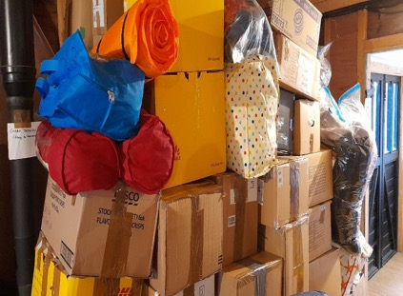

**We are sincerely grateful to all who donated!**

**Our lovely ladies have knitted squares for over 130 blankets so far, and are still knitting. A big ‘Thank You’ to these Ladies, excellent work by you all. The lady in charge at the Barn collecting for Ukraine emailed me and said, “Those Blankets were so colourful and knitted with love.” I’d call that a Pat on the Back. Well Done.**

**We must remember that we have lost some of our members during the lockdown. They will always be in our thoughts.**

**So we’re all looking forward to a fun year, this year, when we can forget the time and trials of the last year and a half.**

**Best to All our Sister Clubs - hope all is well with you.**

**From RAMARA (Ramsgate). Secretary.**

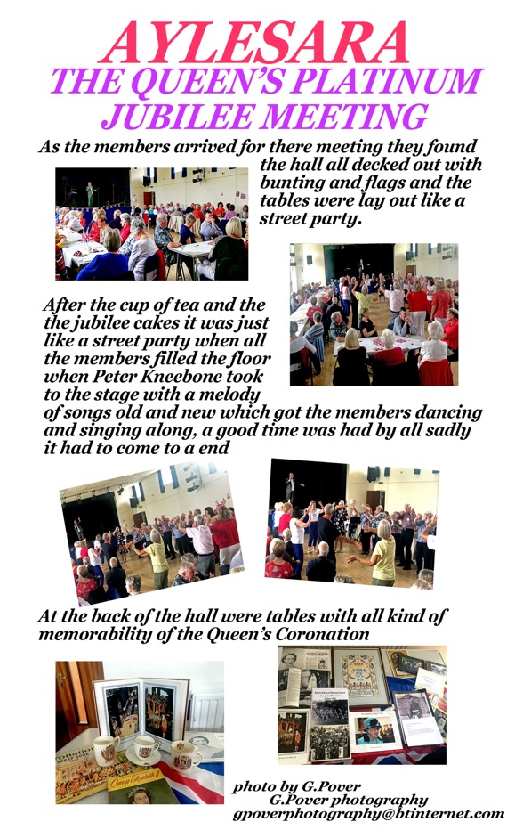

**LordARA - Celebration Time!**

**LordARA, which opened its doors in July 2018 has, despite Covid and lockdowns, reached 100 members. Amazing and cause for celebration, we believe! This hasn’t happened by accident. A dedicated team of committee members has worked together to make LordARA a success.**

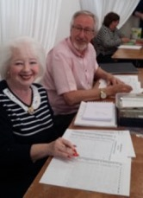

**Pat and Keith log our members in and are happy with how many are attending. Great job!**

**Monthly newsletters keep members informed; speakers and/or activities are arranged every month to entertain the members; pub lunches and trips are well-organised, varied and well-supported; welfare of members is given high priority and a range of activities happen every month. Kurling, Tenpin Bowling, Arts & Crafts and, most recently, tai chi take place at different times each month so members have a range of activities they can attend.**

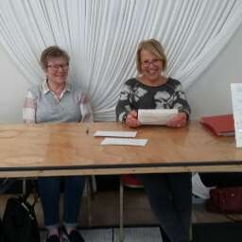

**Jeanette & Lynne organising our trips and doing a brilliant job.**

**Fun is high on the agenda. We’re proud of what we’ve achieved and keen to provide even more. Watch this space!**

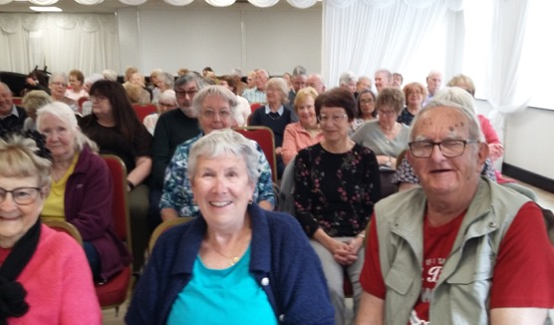

**Members enjoying the speaker, Alan Haines. He was hilarious!!**

**RoffARA**

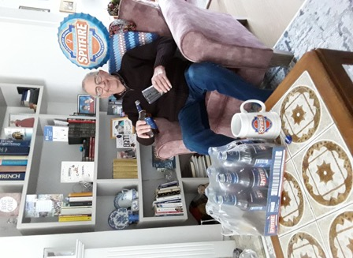

**Former, former KentARA Secretary Brian Griffin, celebrates his 80th birthday with a gift of 80 bottles of Shepherd Neame’s ‘Spitfire’ beer, and associated Breweriana, from his local ARA in Rochester.**